Description of courses which address Professional Ethics
- Cosmetology
- B.A Semester I
- B.A Semester II
- B.A Semester VI
- PG Diploma in Cosmetology Semester I
- M.Voc.(C&W) Semester III
- Bachelor of Design
- BACHELOR OF DESIGN (SEMESTER-III)
- BACHELOR OF DESIGN (SEMESTER-V)
- BACHELOR OF DESIGN (SEMESTER-VI)
- BACHELOR OF DESIGN (SEMESTER-VIII)
- English
- B.A./B.Sc./ B.ComSemester V
- M.A. Semester I
- M.A. Semester II
- M.A. Semester IV
- B.Voc (Banking & Financial Services) Semester IV
- BBA Semester I
- B.Com (Hons) semester VI
- MCom Semester II
- Fashion Designing
- B.Sc(FD) Sem I P-IV
- B.Sc(FD) Sem II P-V
- B.Voc ( FT) Sem II P-I
- M.Sc.( FD) Sem I P-VI
- M.Sc.( FD) Sem II P-V
- M.Sc.( FD) Sem III P-VII
- M.Sc.( FD) Sem IV P-VI

- Diploma in Counselling semester I P-I
- B.Sc (BT) Semester III
- B.VOC.(MHC) Semester I P-I
- B.VOC.(MHC) Semester I P-II
- B.VOC.(MHC) Semester VI P-III

Proofs related to courses which address Professional Ethics

Professional ethics
B.A./B.Sc. (Semester System) (12+3 System of Education) (Semester–I) (Faculty of Sciences)

SEMESTER–I COSMETOLOGY (VOCATIONAL)
(THEORY)
Time: 3 hrs. Max. Marks: 100
Periods/Week-6 Theory Marks: 40
Practical Marks: 60
Instructions for the Paper Setters:-
Eight questions of equal marks (Specified in the syllabus) are to be set, two in each of the four Sections (A-D). Questions may be subdivided into parts (not exceeding four). Candidates are required to attempt five questions, selecting at least one question from each Section. The fifth question may be attempted from any Section.

OBJECTIVES
To create awareness about the cosmetology
To impart knowledge of skin and personal grooming

SECTION–A

Cosmetology
- Introduction
- Aims and Importance

Skin:
- What is Skin?
- Structure of skin
- Functions of skin
- Types of skin
- Common skin problems

Personal Grooming:
- Personal Hygiene

SECTION–B

SECTION–C

- Care of mouth, teeth, ears, feet, removing body hair, skin care and cosmetics, care of hair, nail and hand care, care of your clothing.

SECTION–D
Massage:
- Theory of massage
- Benefits of massage
- Basic knowledge of facial muscles
Reference Books:
- The complete book of beauty by Sunnydale, halena
- Standard Text book of Cosmetology by Miladi
- Text book of Cosmetics by Vimla Devi M
- Instant skin care, how to have health hassle free skin by Nortan Sally

B.A./B.Sc. (Semester System) (12+3 System of Education) (Semester–II) (Faculty of Sciences)

SEMESTER–II COSMETOLOGY (VOCATIONAL)
(THEORY)
Time: 3 hrs. Total Marks: 100
Periods/Week-6 Theory Marks: 40
Practical Marks:60
Instructions for the Paper Setters:-
Eight questions of equal marks (Specified in the syllabus) are to be set, two in each of the four Sections (A-D). Questions may be subdivided into parts (not exceeding four). Candidates are required to attempt five questions, selecting at least one question from each Section. The fifth question may be attempted from any Section.

OBJECTIVES
To create awareness about the colours & yoga To impart knowledge of Nails and Visual Poise

SECTION–A

Nail
- Structure of nail
- Disorder and Disease of the nails

Colours

SECTION–B

- Basic knowledge of colours: Primary & Secondary.
- Colours, effects and selection acc. To season and occasion.
- Planning of wardrobe and acc. To figure, complexion, occupation and weather.

SECTION–C
Visual Poise
- Corrective stance, standing, walking, sitting.

SECTION–D
Yoga
- What is Yoga?
- Role of Yoga for a good health.
References Books:
- The complete book of beauty by Sunnydale, halena
- Standard Text book of Cosmetology by Miladi
- Text book of Cosmetics by Vimla Devi M
- Instant skin care, how to have health hassle free skin

B.A./B.Sc. (Semester System) (12+3 System of Education) (Semester–VI) (Faculty of Sciences)

SEMESTER–VI COSMETOLOGY (VOCATIONAL)
(THEORY)
Time: 3 hrs. Max. Marks: 100
Periods/Week: 4 Theory Marks: 35
Practical Marks: 50 College Lab Training Marks: 15
Instructions for the Paper Setters:-
Eight questions of equal marks (Specified in the syllabus) are to be set, two in each of the four Sections (A-D). Questions may be subdivided into parts (not exceeding four). Candidates are required to attempt five questions, selecting at least one question from each Section. The fifth question may be attempted from any Section.

COURSE CONTENTS:

Salon Management
- Salon Planning
- Types of Salon Ownership

Salon Records and Professional Ethics

Record Keeping
SECTION–A

SECTION–B

- Types of Services Offered, Types of Employers
- Professional Ethics as an employee, co-worker, as an operator
SECTION–C
Safety Precautions
- Health and safety risk
- Accidents due to chemicals, electric equipments, services
- Consultation
- Emergency Procedure
- First Aid in Salon
SECTION–D
Chemical Treatment of Hair
- Permanent waving Procedure with the knowledge of hair porosity
- Classification of hair colouring: Application of temporary hair colour, semi-permanent hair colour and permanent hair colour

PG DIPLOMA IN COSMETOLOGY (SEMESTER-I) Paper – I (Theory) PERSONALITY DEVELOPMENT
Time: 3 hrs M. Marks: 50
6 period per week
Instructions for the Paper Setters:
Eight questions of equal marks (Specified in the syllabus) are to be set, two in each of the four Sections (A-D). Questions may be subdivided into parts (not exceeding four). Candidates are required to attempt five questions, selecting at least one question from each Section. The fifth question may be attempted from any Section.
OBJECTIVES
To impart knowledge about Cosmetology and PersonalGrooming Awareness about Hygiene and Bacteriology

COSMETOLOGY:
Introduction and Importance of Cosmetology

PERSONAL GROOMING:
Colour and outfit culture:
SECTION-A SECTION-B

- Colours:- Importance, effects and selection.
- Planning and Wardrobe and Selection of Clothes according to figure, physique,
- complexion, occupation and weather.
- Selection of accessories according to attire and occasion.
- Use of perfumes
Visual Poise
- Basic Stance and Corrective Stance.
- Basic hand positions and expressive and graceful hand free actions.
- correct different sitting positions and sitting on a low stool or bench.
- Walking correctly.
- Correct sleeping position.
- Getting in and out of cars
- Meeting and greeting people, party and table manner; entering and leaving properly.
- Handling coats, shawls and stoles, gloves and hand bags.

Speaking and Conversational charm:
- Characteristics of Charming conversationalist, topics of conversation, topics to
- avoid, manners of pleasant conversation, when to speak and when to listen.
- Voice cultivation, enunciation and pronunciation.
SECTION-C
PERSONAL HYGIENE:
- Professional appearance and Good Grooming.
- Personal Hygiene and Healthy Habits.
SECTION-D
BACTERIOLOGY: (In Short only)
- What is Bacteria? ◻ Types of Bacteria
- Growth and Reproduction of Bacteria

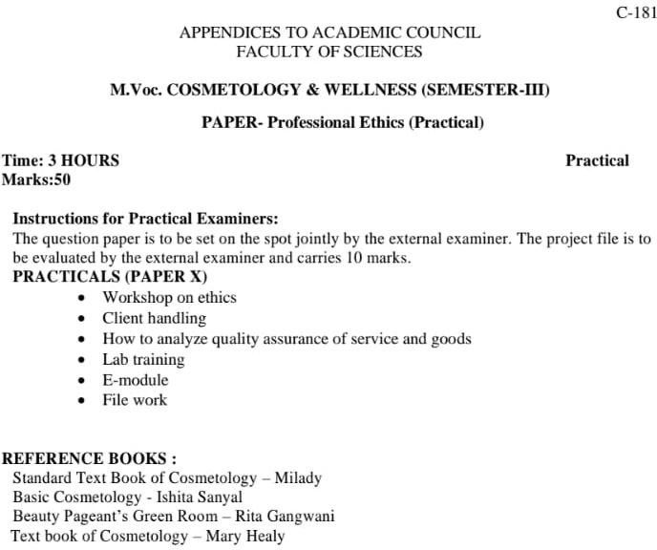

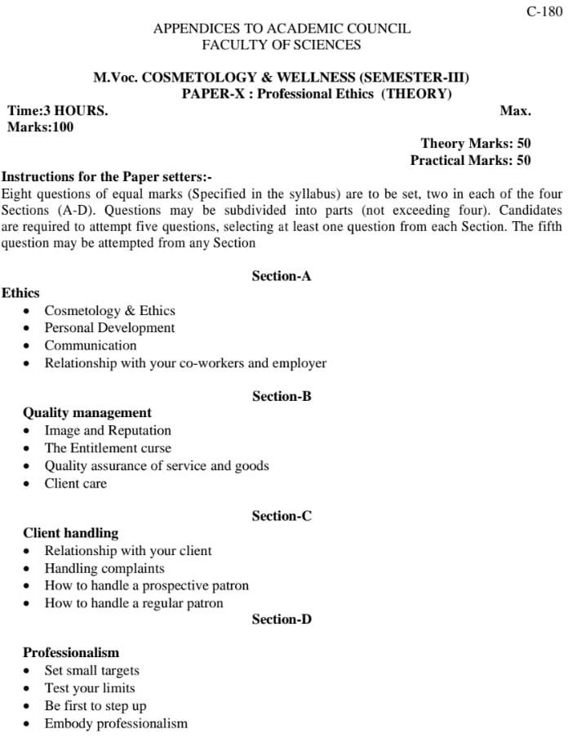

BACHELOR OF DESIGN (SEMESTER SYSTEM) SEMESTER-III
VII. ADVERTISING & MARKETING (THEORY) (COMMON TO ALL SPECIALIZATIONS)
Time: 3 Hrs Total: 75 Marks
Instruction for the Examiners (Theory):
Eight questions are to be set by selecting two questions from each section. Each question is divided in sub sections(not exceeding 4). The candidates are required to attempt five questions by selecting one question from each section and the fifth question can be attempted from any section. All questions carry equal marks.
SECTION-A
- Definition of Marketing
  - The Marketing Concepts and its Evolution
(Production Concept, Selling Concept, Marketing Concept)
  - Product and Societal Marketing
  - Benefits of the Marketing Concepts
SECTION-B
- The Marketing Mix
  - The concept and elements of the Marketing mix the 4P’s and their sub elements
  - Factors considered for designing an appropriate marketing mix.
- Market Segmentation and Targeting
  - Concepts and base of Segmentation
  - Benefits of Segmentation
  - Characteristics of Profitable Segments–Market Targeting Strategies.
- Products
  - Basic Concept
  - Product Life Cycle
  - Marketing Strategies for different stages of PLC
SECTION-C
- ProductBranding
  - Important Branding
  - Purpose of Branding
  - Branding Strategies
  - Characteristics of good brand names
- Product Packaging
  - Basic Purpose Types of Packages
  - Important decision areas– size, share, materials, colours, dual use of packages changes in package design, pre-testing of package.
SECTION-D
- Direct Marketing
  - Nature
  - Growth
  - Advantages
  - Major Decisions
- Advertising
  - Need & Importance to whole salers, retailers and consumers
  - Advantages
  - Role of advertising in the marketing mix.

BACHELOR OF DESIGN (SEMESTER SYSTEM) (SEMESTER–V)
VII. BUSINESS STUDIES–II (COMMON TO ALL SPECIALIZATION)
Time: 3 Hrs. Theory: 75 Marks
Instruction for the Examiners (Theory):
Eight questions are to be set by selecting two questions from each section. Each question is divided in sub sections(not exceeding 4). The candidates are required to attempt five questions by selecting one question from each section and the fifth question can be attempted from any section. All questions carry equal marks

SECTION–A
- Finance Function
  - Objectives and scope of Financial Management
  - Financial Planning
  - Sources of Finance

- Personnel Functions
  - Nature & Scope of Personnel Management
  - Manpower Planning

SECTION–B

SECTION–C

- Management Planning Functions ◻ ◻Meaning
  - Aim & Importance
  - Limitations
  - Characteristics of a good plan
  - Types of plans
  - Steps in the planning process

SECTION–D
- Sales Function
  - Traditional & Modern Concepts
  - Steps in the selling process
  - Sales forecasting
  - Sales Promotion
  - Sales Force Management

BACHELOR OF DESIGN (SEMESTER SYSTEM) (SEMESTER–VI)
V. ENTREPRENEURSHIP DEVELOPMENT PROGRAMME (COMMON TO ALL SPECIALIZATION)
Time: 3 Hrs. Total: 75 Marks
Instruction for the Examiners (Theory):
Eight questions are to be set by selecting two questions from each section. Each question is divided in sub sections (not exceeding 4). The candidates are required to attempt five questions by selecting one question from each section and the fifth question can be attempted from any section. All questions carry equal marks.
The Course is designed for 30 hours duration and would deal with the subject on entrepreneurship including Project Management. The course will assist the person to develop and
in sight in to entrepreneurship understand and develop the traits that make a successful entrepreneur. It will assist him/her to formulate his/her venture and launch the same. The details of topics along with duration are given below:

SECTION-A
Entrepreneurship and its Traits
Why entrepreneurship, who is an entrepreneur (Characterstics of a good entrepreneur)
Entrepreneurship Motivation training
(Development entrepreneur’s traits through behaviour exercises)

SECTION-B
Project concept and Planning
Method of Product Identification and Procedures and formalities Concept of Project Report–covering aspects like management

SECTION-C
Site selection, and Building Technology and Technical Know–how Selection of Plant and Machinery, Plant Capacity, Utilities requirements etc.

SECTION-D
Project financing and Viability
Project Cost and Capital Structure
Estimating Cost of Production and Profitability

Total Marks: 300

BACHELOR OF DESIGN (SEMESTER SYSTEM) (SEMESTER–VIII)
(FASHION, TEXTILE, INTERIOR DESIGN) INDUSTRIAL TRAINING

  - Industrial training for minimum 8–10 weeks.
  - Report to be submitted
ENGLISH
Professional Ethics:

(B.A/B.Sc/B.Com-Sem V)
All My Sons by Arthur Miller

(M.A-Sem I and II)
Hard Times by Charles Dickens (Paper-III)
Heart of Darkness by Joseph Conrad (Paper-VIII)
SEMESTER–V ENGLISH COMPULSORY
Time: 3 Hours Max. Marks: 50
Instructions for the Paper Setters:-
Eight questions of equal marks (Specified in the syllabus) are to be set, two in each of the four Sections (A-D). Questions may be subdivided into parts (not exceeding four). Candidates are required to attempt five questions, selecting at least one question from each Section. The fifth question may be attempted from any Section.
Texts Prescribed:
- All My Sons by Arthur Miller
- Poems of Nature and Culture, Guru Nanak Dev University, Amritsar
Poems of Nature and Culture
William Wordsworth: “The World is Too Much with Us” Gordon Lord Byron: “She Walks in Beauty”
P.B. Shelly: “Ozymandias”, Alfred Lord Tennyson: “In Memoriam” Robert Browning: “Meeting at Night”,Mathew Arnold: “Dover Beach”
W.B. Yeats: “Words”
Wilfred Owen: “Strange Meeting” Robert Graves: “The Portrait”
W.H. Auden: “The Unknown Citizen”
Dylan Thomas: “Do not Go Gentle into That Good Night” Ted Hughes: “The Thought-Fox”
Sylvia Plath: “Mirror”
Seamus Heaney: “Honeymoon Flight” Rabindranath Tagore: “False Religion” Nissim Ezekiel: “Night of Scorpion”
- Formal letter and application writing, Resume Writing, Business Writing and Report writing
The syllabus is divided into four sections as mentioned below:
Section A- All My Sons by Arthur Miller the whole text.
Section B- Poems of Nature and Culture Guru Nanak University, Amritsar. Section C- Formal Letter and Application Writing.
Section D- Business Writing and Report Writing, Resume Writing
Instructions for the paper-setter and distribution of marks:

The question paper will consist of four sections and distribution of marks will be as under: The question paper will be divided into four sections:
SECTION–A
Section A will consist of two questions. Question one will consist of three short answer questions and the students are required to attempt any two. Each question will carry 4 marks. (2X4=8). Total weightage of this section is 15 marks.
Question two, an essay type question with internal choice will be set. It will carry 7 marks. (1X7=7)
SECTION–B
Three short answer type questions based on the central idea, theme, tone or style etc. of the prescribed poems will be set. The students are required to attempt any two. Each question carries three marks. (2x3=6) One question with internal choice requiring the students to explain a stanza with reference to the context will be set. (1x4=4) It carries four marks. One essay- type question with internal choice from the poems prescribed will be set. It carries five marks. (1x5=5). Total weighage of this section is 15 marks.
SECTION–C
Two questions will be set in this section. One question will be set on Formal Letter Writing. It carries five marks. Another question on Application Writing will be set. It also carries five marks. (5+5=10)
SECTION–D
Two questions will be set in this section. One question will be on Resume Writing/ Business
Writing. It carries five marks. Another question based on ReportWriting will be set. It carries five marks. (5+5=10)

M.A. ENGLISH SEMESTER–I
PAPER–III: ENGLISH NOVEL (UPTO 19TH CENTURY)
Time: 3 Hours Max. Marks: 80
Instructions for the Paper Setters:-
Eight questions of equal marks (Specified in the syllabus) are to be set, two in each of the fourSections (A-D). Questions may be subdivided into parts (not exceeding four). Candidates arerequired to attempt five questions, selecting at least one question from each Section. The fifthquestion may be attempted from any Section.
SECTION–A

Henry Fielding: Joseph Andrews Jane Austen: Pride and Prejudice Charles Dickens: Hard Times
Thomas Hardy: Jude the Obscure
Suggested Reading:-

SECTION–B SECTION–C SECTION–D

- Walton Litz. Jane Austen: A Study of Her Artistic Development. London: Chatto& Windus, 1965.
- Allan Grant. A Preface to Dickens. London: New York, 1984.
- Judith O’Neill, Ed. Critics on Jane Austen. Florida: University of Miami Press, 1977.
- B.C. Southam. Critical Essays on Jane Austen. London: Routledge, 1968.
- David Lodge, Ed. Emma: A Casebook. London: Macmillan. 1968
- Draper, R. P., Ed. Hardy: The Tragic Novels (A Casebook). London: Macmillan, 1975.
- Elizabeth Jenkins. Henry Fielding. London: Arthur Barker, 1966.
- Glenn W. Hatfield. Henry Fielding and the Language of Irony. Chicago & London: The University of Chicago Press, 1968.
- Guerard, Albert J., Ed. Hardy: A Collection of Critical Essays. New Jersey: Prentice-Hall, 1963.
- Harold Bloom, Ed. Jane Austen's Emma: Modern critical interpretations. New York: Chelsea House, 2010.
- K.J. Fielding. Charles Dickens: A Critical Introduction. London: Longmans, 1965
- Lionel Trilling. “Emma and the Legend of Jane Austen.” Beyond Culture: Essays on

M.A. ENGLISH SEMESTER–II
PAPER–VIII: MODERN NOVEL
Time: 3 Hours Max. Marks: 80
Instructions for the Paper Setters:-
Eight questions of equal marks (Specified in the syllabus) are to be set, two in each of the fourSections (A-D). Questions may be subdivided into parts (not exceeding four). Candidates arerequired to attempt five questions, selecting at least one question from each Section. The fifthquestion may be attempted from any Section.

Suggested Reading:-

SECTION–A
D.H. Lawrence: Sons and Lovers

SECTION–B
Virginia Woolf: Mrs Dalloway

SECTION–C
Joseph Conrad: Heart of Darkness

SECTION–D
William Golding: Lord of the Flies

- Bose, Bindra, ed. Heart of Darkness. New Delhi: Oxford University Press, 2001.
- Curle, Richard. Joseph Conrad and His Characters: A Study of Six Novels. London: Heinemann, 1968.
- Anne Fernihough. The Cambridge Companion to D.H. Lawrence. Cambridge University Press, 2001.
- Keith Sagar. D.H. Lawrence: Life into Art. New York: Penguin, 1986.
- Gamini Salgado, ed. Sons and Lovers: A Casebook. London: MacMillan, 1969.
- Linda Ruth Williams. D. H. Lawrence (Writers and their Work). New Delhi: Atlantic, 2010.
- Harold Bloom, Virginia Woolf’s Mrs. Dalloway (Bloom’s Modern Critical Interpretations), London: Chelsea House Publications, 1988.
- Dowling, David. Mrs Dalloway: Mapping Streams of Consciousness. New York: Twayne Publishers, 1991.
- Bose, Brinda, Ed. Mrs Dalloway: Worldview Critical Editions. New Delhi: Worldview Publications, 2001.
- Chakoo, B. L., ed. William Golding Revisited. Bangalore: Arnold-Heinemann, 1987.
- Harold Bloom, ed. William Golding’s “Lord of the Flies.” New Delhi: Viva, 2007.
- Kevin McCarron. William Golding (Writers and their Work). New Delhi: Atlantic, 2010.
- Norman Page. Ed. William Golding: Novels, 1954-67 (A Casebook). Hampshire and London: MacMillan, 1985.

BACHELOR OF VOCATION (B.Voc.)

BANKING & FINANCIAL SERVICES (SEMESTER SYSTEM) SEMESTER–IV
BVC-401: BUSINESS ETHICS AND CORPORATE SOCIAL RESPONSIBILITY
Time: 3 Hours Max. Marks: 50
Instructions for the Paper Setters:-
Eight questions of equal marks (Specified in the syllabus) are to be set, two in each of the four Sections (A-D). Questions may be subdivided into parts (not exceeding four). Candidates are required to attempt five questions, selecting at least one question from each Section. The fifth question may be attempted from any Section.

SECTION-A
Business Ethics: Definition and nature, Importance of business ethics, Emerging business ethics issues, Business ethics in a global economy
Environmental ethics, Marketing ethics, Corporate ethics, Ethical issues in HRM.

SECTION-B
Ethical theories; Ethical dilemmas, Sources and their resolutions. Individual factors: Moral philosophies, Organizational factors: The role of ethical culture and relationships. Value based organizations

SECTION-C
Concept of Corporate Social Responsibility (CSR), Historical phases of CSR, Perspectives on CSR, CSR models, Drivers of CSR, CSR: Within the organisation, CSR and Society. Corporate social responsibility practices in India.

SECTION-D
Corporate governance: Principles, Issues and Trend Ethical decision making in business and ethical leadership Suggested Readings:
- Roa, F.C. “Business Ethics and Social Responsibility”, Rex Book Store, Manila, Philippines.
- Ghosh, B.N., “Business Ethics and Corporate governance”, Tata McGraw Hill.
- Bhatt, K. and Sumitha, A., “Business Ethics and Corporate Social Responsibility”, Himalaya Publications
- Hartman, L., and DesJardins, J., “Business Ethics: Decision-Making for Personal Integrity &SocialResponsibility”, Tata McGraw Hill.
- Fernando, A.C., “Business Ethics and Corporate Governance”, Dorling Kindersley (India) Pvt Ltd.
- Bhanu Murthy, K.V. and Usha Krishna, “Politics Ethics and Social Responsibilities of Business”, earson Education, New Delhi.
- Laura P. Hartman and Joe Des Jardins, “Business Ethics: Decision–Making for Personal Integrity andSocial Responsibility”, NY: McGraw–Hill/Irwin.
- Ferrell, O.C., Fraedrich, John, and Ferrell, Linda, “Business Ethics, Ethical Decision Making &Cases”,Prentice Hall, Boston
- V. Balachandran and V. Chandrasekaran, “Corporate Governance and Social Responsibility”, PHI Learning Private Limited, New Delhi.
- Murthy, “Business Ethics and Corporate Governance”,Himalaya

B.COM (PASS & HONS.) (SEMESTER-I) BCG–104: BUSINESS ORGANISATION
Time: 3 Hours Max. Marks: 50
Instructions for the Paper Setters:-
Eight questions of equal marks (Specified in the syllabus) are to be set, two in each of the four Sections (A-D). Questions may be subdivided into parts (not exceeding four). Candidates are required to attempt five questions, selecting at least one question from each Section. The fifth question may be attempted from any Section.

SECTION-A
Business: Meaning and types – profession – meaning and importance of business organization. Social Responsibilities of Business – Business Ethics.

SECTION-B
Forum of Business organization – sole trader – partnership – joint Hindu family – joint stock companies – co–operative societies – public utilities and public enterprises.
Public Sector vs. Private sector

SECTION-C
Location of industry – factors influencing location – size of industry – optimum firm – advantages of large – scale operation – limitation of small scale operation – Industrial estates – District Industries Centres.

SECTION-D
Stock Exchange – Function – Types – Working – Regulation of Stock Exchange in India. Business Combination – Causes – Types – Effects of Combination in India.
Trade association –Chamber of commerce – Function – Objectives Working in – India.
Suggested Readings:
- Bhusan, Y.K. “Fundamentals of Business Organisation and Management”, 1980, Sultan Chand & Sons, New Delhi.
- Tulsian, P.C.andPandey V., “Business Organisation and Management”, 2009, Pearson Education, New Delhi
- Talloo, T.J., “Business Organisation and Management”, 2008, Tata McGraw Hill Company, New Delhi
- Basu, C.R., “Business Organisation and Management”, 2010, Tata McGraw Hill Company, New Delhi
- Singla, R.K., “Business Organisation & Management”, 2011, VK (India) Enterprises, New Delhi.

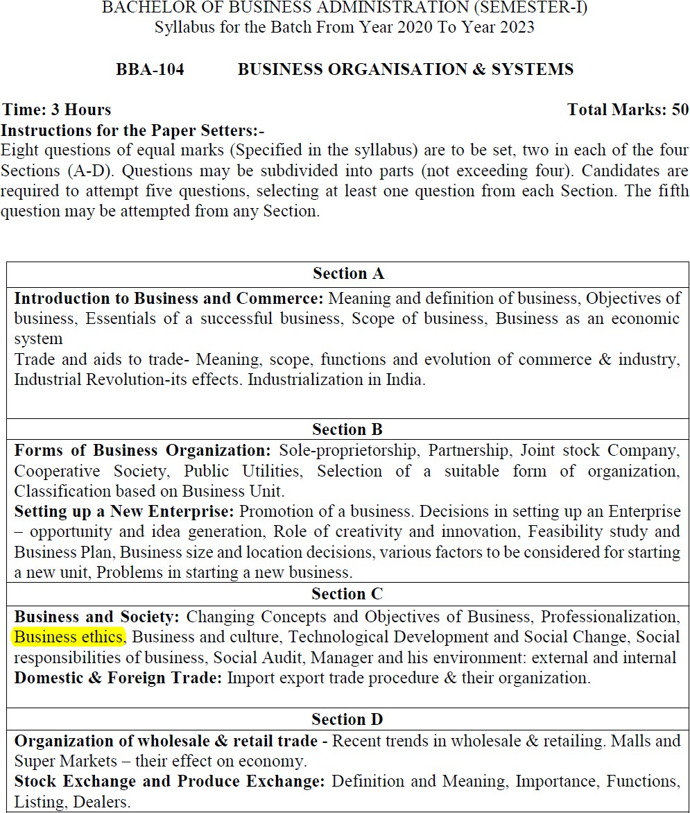

B.COM (PASS & HONS.) (SEMESTER-VI) BCG–604:CORPORATE GOVERNANCE
Time: 3 Hours Max.Marks: 50
Instructions for the Paper Setters:-
Eight questions of equal marks (Specified in the syllabus) are to be set, two in each of the four Sections (A-D). Questions may be subdivided into parts (not exceeding four). Candidates are required to attempt five questions, selecting at least one question from each Section. The fifth question may be attempted from any Section.

SECTION-A
Ethics in Business:Concept of Business Ethics. Corporate Code of Ethics: Environment, Accountability, Responsibility, Leadership, Diversity, Discrimination.
Principles of Business Ethics, Characteristics of Ethical Organisation, Theories of Business Ethics, Globalization and Business Ethics, Stakeholder’s Protection, Corporate Governance and Business Ethics.
Corporate Governance: Conceptual framework of Corporate Governance, Insider Trading, Rating Agencies, Whistle Blowing,

SECTION-B
Corporate Governance Reforms, Initiatives in India including clause 49.
Major Corporate Scandals: Junk Bond Scam (USA), Enron (USA), WorldCom (USA), Tyco (USA), Andersen Worldwide (USA), Kirch Media (Germany), Vivendi (France), Parmalat (Italy) and Satyam Computer Services Ltd (India),

SECTION-C
Common Governance Problems Noticed in various Corporate Failures, Is Corporate Governance always the Cause for Corporate Failures?
Codes & Standards on Corporate Governance: Sir Adrian Cadbury Committee (UK), 1992 ,Calpers Global Corporate Governance Principles (USA), 1996, Hampel Committee on Corporate Governance (UK), 1997, Combined Code of Best Practices (London Stock Exchange), 1998,

SECTION-D
OECD Principles of Corporate Governance, 1999, CACG Guidelines/Principles for Corporate Governance in Commonwealth, 1999, Euroshareholders Corporate Governance Guidelines, 2000, Principles of Good Governance and Code of Best Practice (UK), 2000, Sarbanes–Oxley (SOX) Act, 2002 (USA), Smith Report, 2003 (UK)
Suggested Readings:
- Murthy, K.V. Bhanu and Krishna, U., “Politics Ethics and Social Responsibilities of Business”, 2009, Pearson Education, New Delhi.
- Sharma, J. P., “Corporate Governance, Business Ethics & CSR”, 2011, Ane Books Pvt. Ltd., New Delhi.
- Mallin, C., “Corporate Governance” (Indian Edition), 2012, Oxford University Press, New Delhi.
- Tricker, B., “Corporate Governance–Principles, Policies, and Practice”, (Indian Edition), 2012, Oxford University Press, New Delhi.
- Crane, A. and Matten, D., “Business Ethic” (Indian Edition), 2003, Oxford University Press, New Delhi.
- Albuquerque, D., “Business Ethics, Principles and Practices”, (Indian Edition), 2010,Oxford University Press, New Delhi.
- Blowfield, M. and Murray, A., “Corporate Responsibility–A Critical Introduction”, 2008, Oxford University Press

MASTER OF COMMERCE (SEMESTER-II)
MC–201: CORPORATE FINANCIAL ACCOUNTING AND AUDITING
Time: 3 Hours Max. Marks: 100
Instructions for the Paper Setters
Eight questions of equal marks (Specified in the syllabus) are to be set, two in each of the four Sections (A-D). Questions may be subdivided into parts (not exceeding four). Candidates are required to attempt five questions, selecting at least one question from each Section. The fifth question may be attempted from any Section.

SECTION-A
- Company Final Accounts–Requirements of Companies Act, 2013.
- Form and contents of Profit and loss account statement and balance sheet.
- Managerial remuneration. Meaning of profit.Divisible profits.

SECTION-B
- Valuation of goodwill, different approaches such as super profit, annuity and capitalization approach.
- Valuation of shares; different approaches such as book value and earnings approach.

SECTION-C
- Understanding the concept and rationale of Financial Audit, Cost Audit, Management Audit, Internal Audit, Proprietary Audit, Efficiency Audit and Audit by C. and A.G.,
- Statutory Auditor–Appointment qualifications, removal. Duties and liabilities of auditor. Code of conductand ethics, professional misconduct of statutory auditor.

SECTION-D
- Meaning, Objectives and scope of cost audit. Cost Auditor, his appointment, duties liabilities. Cost audit report; Meaning, objectives and scope of management audit. Appointment and qualifications of management Auditor.
- Audit of management functions such as planning, organising and control. Audit of functional areas–production, personnel marketing finance and accounting.
Suggested Readings:
- Khan, M.Y. and Jain, P.K., “Financial Management”, 5th edition, Himalaya Publishing, New Delhi
- Pandey I.M., “Financial Management”, 9th edition (2009), Vikas Publishing House.
- Gupta, Kamal, “Contemporary Auditing”, 6th edition, Tata McGraw Hill.
- Sehgal, Ashok and Sehgal, Deepak, “Advanced Accounting”, 3rd edition, Taxman, New Delhi.
- Maheshwari, S.N. and Maheshwari, S.K., “Corporate Accounting”, 5th edition (2009),

B.Sc. Fashion Designing (Semester–I) (PROFESSIONAL ETHICS)
PAPER-VI : COMMUNICATION SKILLS IN ENGLISH-I

Time:3Hours Max. Marks:50
Instructions for the Paper Setters:-
Eight questions of equal marks (Specified in the syllabus) are to be set, two in each of the four Sections (A-D). Questions may be subdivided into parts (not exceeding four). Candidates are required to attempt five questions, selecting at least one question from each Section. The fifth question may be attempted from anySection.

Thesyllabusisdividedinfoursectionsasmentionedbelow:
Section–A
Reading Skills: Reading Tactics and strategies; Reading purposes–kinds of purposes and associated comprehension; Reading for direct meanings.
Section–B
Reading for understanding concepts, details, coherence, logical progression and meanings of phrases/ expressions.
Activities:
  - Comprehension questions in multiple choiceformat
  - Short comprehension questions based on content and development ofideas
Section–C
Writing Skills: Guidelines for effective writing; writing styles for application, personal letter, official/ businessletter.
Activities
  - Formatting personal and business letters.
  - Organising the details in a sequential order
Section–D
Resume, memo, notices etc.; outline and revision.

Activities:
  - Converting a biographical note into a sequenced resume orvice-versa
  - Ordering and sub-dividing the contents while makingnotes.
  - Writing notices for circulation/boards

Recommended Books:
  - Oxford Guide to Effective Writing and Speaking by JohnSeely.
  - English Grammar in Use (Fourth Edition) by Raymond Murphy,CUP

B.Sc. Fashion Designing (Semester–II) (PROFESSIONAL ETHICS)
PAPER–V: COMMUNICATION SKILLS IN ENGLISH-II

Time: 3 Hours

Instructions for the Paper Setters:-

Max. Marks:50 Theory Marks:35 Practical Marks:15

Eight questions of equal marks (Specified in the syllabus) are to be set, two in each of the four Sections (A-D). Questions may be subdivided into parts (not exceeding four). Candidates are required to attempt five questions, selecting at least one question from each Section. The fifth question may be attempted from anySection.

Course Contents:
SECTION–A
Listening Skills: Barriers to listening; effective listening skills; feedback skills.
Activities: Listening exercises – Listening to conversation, News and TV reports
SECTION–B
Attending telephone calls; note taking and note making.
Activities: Taking notes on a speech/lecture
SECTION–C
Speaking and Conversational Skills: Components of a meaningful and easy conversation; understanding the cue and making appropriate responses; forms of polite speech; asking and providing information on general topics.
Activities: 1) Making conversation and taking turns
2) Oral description or explanation of a common object, situation or concept
SECTION–D
The study of sounds of English, Stress and Intonation,
Situation based Conversation in English, Essentials of SpokenEnglish.
Activities: GivingInterviews

Course Contents:-
PRACTICAL / ORAL TESTING
Marks: 15
- Oral Presentation with/without audio visualaids.
- GroupDiscussion.
- Listening to any recorded or live material and asking oral questions for listening comprehension.
Questions:-
- OralPresentationwillbeof5to10minutesduration(Topiccanbegiveninadvanceorit can be student’s own choice). Use of audio visual aids is desirable.
- Group discussion comprising 8 to 10 students on a familiar topic. Time for each group will be 15 to 20minutes.

Note: Oral test will be conducted by external examiner with the help of internal examiner.

B.VOC FASHION TECHNOLOGY SEMESTER I (PROFESSIONAL ETHICS)
Paper-I: COMMUNICATION SKILLS IN ENGLISH-I
Time:3Hours Max. Marks: 50
Instructions for the Paper Setters:-
Eight questions of equal marks (Specified in the syllabus) are to be set, two in each of the four Sections (A-D). Questions may be subdivided into parts (not exceeding four). Candidates are required to attempt five questions, selecting at least one question from each Section. The fifth question may be attempted from any Section.

The syllabus is divided in four sections as mentioned below:
Section–A
Reading Skills: Reading Tactics and strategies; Reading purposes–kinds of purposes and associated comprehension; Reading for direct meanings.

Section–B
Reading for understanding concepts, details, coherence, logical progression and meanings of phrases/ expressions.

Activities:
- Comprehension questions in multiple choiceformat
- Short comprehension questions based on content and development ofideas

Section–C
Writing Skills: Guidelines for effective writing; writing styles for application, personal letter, official/ business letter.

Activities
- Formatting personal and business letters.
- Organising the details in a sequentialorder

Section–D
Resume, memo, notices etc.; outline and revision.

Activities:

- Converting a biographical note into a sequenced resume orvice-versa
- Ordering and sub-dividing the contents while makingnotes.
- Writing notices for circulation/boards

Recommended Books:
  - Oxford Guide to Effective Writing and Speaking by JohnSeely.
  - English Grammar in Use (Fourth Edition) by Raymond Murphy,CUP

B.VOC FASHION TECHNOLOGY SEMESTER IV (PROFESSIONAL ETHICS & HUMAN VALUES)
Paper-I: Entrepreneurship (Theory)
Totalmarks:50
Time: 3Hrs. Theory:50

Instructions for paper setters
There will be 7 questions in all. Students are required to attempt 5 questions. (10 Marks each)

Entrepreneurship and Entrepreneur:-
- Definition, meanings and functions of anentrepreneur
- Role of Entrepreneurship in economicdevelopment
- Traits of a goodentrepreneur
- Innovation and entrepreneurship, entrepreneurial behavior andmotivation
Project Planning
- Meaning and importance of a businessplan
- Contents of a businessplan
- Factors affecting siteselection
- Entrepreneurial development programmes- their relevance and achievements. Role of government in organizing suchprogrammes
- Government policies for women entrepreneurs and formalities in setting up aunit
Project Financing and Viability
- Project cost – (fixed and working capital requirement) and estimation of costproduction
- Profitability of theproject
- Contribution of commercial banks in promoting and services in smallbusiness
References-
- Entrepreneurship development, Moharanas and Dash C.R., RBSA Publishing,Jaipure
- Entrepreneurship, Hisrich Peters Sphephard, Tata McGrawHill
- Fundamentals of entrepreneurship, S.K. Mohanty, Prentice Hall ofIndia
- A Guide to Entrepreneurship, David Oates, Jaico Publishing House, Mumbai, Edn2009

Instructions for paper setters
Total marks:50 Time: 3Hrs. Theory:50

There will be 7 questions in all. Students are required to attempt 5 questions. (10 Marks each)

Course Contents:
  - Onlinemarketing-
    - Mobile marketing
    - Advertising
    - Socialnetworking
  - E-commerce in fashiondesigning
  - E-commerce in businessmodels
    - Business to business e-commerce
    - Consumer to consumere-commerce
    - Business to consumere-commerce
  - Product and Subjectdigitization
  - Remote Servicing andProcurement
  - Supply Chain / Value ChainManagement
  - Cyber Laws – aims, features andimportance

References:
- Efrain Turbson, Jae Lee, David King, Chung: Electronic Commerce- AManagerial Perspective, Prentice- HallInternational.
- Greestein, Feinnman: Electronic Commerce, Tata McGraw-Hill.
- Jeffrey F. Rayport, Bernard J. Jaworski: E- commerce, Tata McGrawHill.

M.SC FASHION DESIGNING & MERCHANDISING SEM. I (PROFESSIONAL ETHICS)

Paper-VI
Communication Skills in English (Theory + Practical)
Theory:6pds/week Total Marks:75
Time for Paper:3Hrs. Theory:50
Practical:25
Instructions for the Paper Setters:
Eight questions of equal marks (Specified in the syllabus) are to be set, two in each of the four Sections (A-D). Questions may be subdivided into parts (not exceeding four). Candidates are required to attempt five questions, selecting at least one question from each Section. The fifth question may be attempted from any Section.

SECTION-A
Introduction: Basic Communication, Basic forms of Communication, principles / Concepts of effective Communication

SECTION-B
Reading Skills: Model of Reading to learn – Reading tactics and strategies; Reading Purpose- Kinds of purpose and associated comprehension. Reading outcomes: Paraphrasing / Précis – writing and Summary writing.

SECTION-C
Letter – Writing: Writing styles and formatting of letters, business letters, request letters, good news and bad news letters, Persuasive letters, sales letters, collection letters etc.

SECTION-D
Article Writing on Issues Related to Fashion, Style and Design: How to begin, the topic sentence and the controlling idea, structure, coherence, descriptive writing techniques and critical appreciation.

PRACTICAL

Instructions to the Examiner for Practical/ Oral Exam:
The Practical/ Oral Examination will be conducted by the examiner appointed by GNDU as per rules. The Examiner will test pronunciation of the examinees by giving them oral exercises on Word-Stress and connected speech. The examiner will test the listening skills of the examinees by playing a recorded cassette or by reading out a passage himself / herself and asking questions. He /she may also ask the examinees to take notes.

Pronunciation-7 Listening Comprehension -6
WordStress-7 Note Taking –5
For Practical:
Pronunciation- Introduction of English sounds and their symbols, word- stress features of connected speech – Rhythm, Assimilation, Elision, Linking

Listening Skills
Principles of effective Listening, factors effecting Listening
- Listening to T.V. News / AudioCassettes
- Note –Taking.

Books Recommended:
- John Seely: Oxford Guide to Effective Writing and SpeakingOUP
- GeethaNagaraj – A Course in Grammar and Composition, Foundation Books,2006
- A Course in Listening and Speaking I by V. Sasikumaretal, FoundationBooks.
- English Phonetics and Phonology by Peter Roach, Cambridge UniversityPress.
- Advance learner’s Dictionary (NewEdition).
- English Pronouncing Dictionary, By Daniel Jones, Cambridge UniversityPress.

M.SC FASHION DESIGNING & MERCHANDISING SEM.II (PROFESSIONAL ETHICS)
Paper-V
Fashion Merchandising and Marketing (Theory)

Theory: 4pds/ week Max. Marks –100
Time: 3 hrs
Instructions for the Paper Setters:
Eight questions of equal marks (Specified in the syllabus) are to be set, two in each of the four Sections (A-D). Questions may be subdivided into parts (not exceeding four). Candidates are required to attempt five questions, selecting at least one question from each Section. The fifth question may be attempted from any Section.

SECTION–A

Fashion Terminology: Fashion, Fad, Classic, Style, Trends, Apparel, High Fashion, Mass Fashion, Boutique, Couture, Couturier, Taste, Silhouette.

Theories of fashion Adoption

Fashion Cycle: Stages of Fashion Cycle, length of cycle, broken fashion cycle. Accelerating and Retarding Factors.
Fashion Forecasting: Trend Analysis, Merchandize planning.

SECTION–B

Fashion Business: Introduction, Scope, Forms of Business Organization.
Fashion Merchandising: Introduction, role and responsibility of Merchandiser.Range Development: Product and range development on the basis of fashioncalendar, marketresearch.

SECTION–C
Understanding Marketing and Marketing Process: Nature and scope Strategic Planning in the Markets: The fashion markets and the marketing environment.
Introduction and Development of Fashion Market: Fashion market size and structure.
Market Research: Consumer market and behaviour of consumers.
International and Domestic Fashion Markets: Haute Couture, Prêt – a- Porter, Mass production.
Fashion Markets of World: Italy, Paris, India.

SECTION–D

Advertising - Role and types of Advertising. Sales Promotion: Techniques, Promotionalstores. Fashion Photography – DesignStudios.
Collection Shows, Fashion Shows, Publicity

Books Recommended:
Essential Reading:
- Merchandise Buying & Management, John Donnellan, 2001, FarechildBooks,.
- Kitty G. Dickerson, Inside The Fashion Business, 7th Edition, 2003 Prenticehall
- Elaine Stone, The Dynamics of Fashion, 2004,Fairchild.
- Jay Diamond; Ellon Diamond, The World of Fashion , 2007,Fairchild.

Further Reading:
- Gini Stephens Frings, Fashion from Concepts to Consumer, 1982, Prenticehall,.
- Tony Hines, Fashion Marketing, 2006, Butter Worth –Heinemann.
- Rosemary Varley, Retail Product Managemnet : Buying and Merchandising,2005, Routledge.
- John Giacobello, Careers in fashion Industry, 2000, RoselPub.Group.

M.SC FASHION DESIGNING & MERCHANDISING SEM.III Paper-VII (PROFESSIONAL ETHICS)

RESEARCH METHODOLOGY
Time allowed:3Hrs Total Marks:50
Theory: 6 pds/week

Objective: To introduce the importance of research
To prepare the students for research projects To devise a research project

Instructions to the paper setter: Total 8 questions to be set. Each question carries 10 marks. Unit I- Four questions out of Seven to be attempted. Unit II- One question is compulsory.

UNIT-I

- Research methodology:

- Research process:
- Objectives ofresearch
- Types ofResearch

- Formulating the researchproblem
- Review ofLiterature
- Development ofhypothesis
- Preparing the Research Design: Exploratory, Descriptive, Diagnosis,Experimentation.
- Sampling Design: Deliberate Sampling, Simple Random Sampling, Stratified Sampling,Cluster Sampling.
- Collecting thedata
- Μeasurements and Scaling Techniques-Nominal, Ordinal, Interval and Ratio.
- Processing and analysis of data: Codingand tabulation.
- Introduction and application of measures of central tendency: Mean, Median and mode, Percentage,Chi- square, z-test,t-test.

UNIT-II
  - Plan a research project using a minimum sample of 30 respondents and makea comprehensive layout of the researchproject.

Suggested Readings:
- Cooper, D. R. and Schindler, P.S., “Business Research Methods”, 9th Edition,Tata McGraw Hill, NewDelhi.
- Levine, D.M., Krehbiel T.C. and Berenson M.L., “Business Statistics”, 12th Edition (2012), Pearson Education, NewDelhi.
- Kothari, C. R., “Research Methodology”, 2nd Edition (2008), New AgeInternational.
- Anderson, D.R.; Sweeney, D.J. and Williams, T.A., “Statistics for Businessand Economics”, 2nd Edition (2011), Thompson, NewD

M.SC FASHION DESIGNING & MERCHANDISING SEM. IV (PROFESSIONAL ETHICS)

Paper-V Communication Skills in English

Practical: 6pds/week Total Marks:75
Time:3hrs Theory:50
Practical: 25
Instructions to the Examiner for Theory Exam:
- Introduction video communication and video conferencing. Application of video conferencing in business Management and Marketing.(One question will be set with internal choice.) 8Marks
- Report – Writing withinternalChoice 12Marks
- E-mailorFax 5Marks
- AdvertisementorNotice 5Marks
- a). Resume–Writing 10marks.
b). JobApplication 5Marks
- FiveFashionTerms 5Marks

Unit- I
Introduction to Video Communication and Video Conferencing.Application of Video Conferencing in business management and marketing.

Unit-II
Report Writing: Technical report – style, arrangements, Illustration, main section and appendices, conclusion, list references, table of contents, synopsis, revision.

Unit- III
Modern Forms of Communication: E-mails, fax, Advertisements, tender Notices, auction notices, public notices.

Unit –IV
Resume – Writing and job applications

Unit –V
Fashion Terms: Pliable, Psychedelic, Vogue, Beau (boh) (Pe beaux), Retiro, Queen size, Rag Business/ Rag Trade, private label/ private label brand, Merchandise, Art Deco print, Art Nonveau, Print, Dandy.

Instructions to the Examiner for Practical/ Oral Exam:
Oral presentation with / without audio visual aids on a topic already prepared by the examinee.
10 Marks
  - Written Presentation/Preparation 5Marks.
  - Extempore 5Marks
Topic will be given five minutes before the speech. Topic will be related to Fashion Designing

  - GroupDiscussion 5Marks

For Practical:

Speaking Skills: Components of an effective talk/ Presentation, Planning and organizing content for a talk/ Presentation, use of Visual aids, effective speaking skills, discussion skills, Personality Development
Teamwork, Group Discussion, Public speaking, Interview skills, telephone etiquettes, Attitude Interpersonal skills, Body language.

Books Recommended Essential Readings

  - John Silly: Oxford Guide to Effective Writing and SpeakingOUP.
  - M. Raman, Technical CommunicationOUP
  - GeethaNagaraj – A Course in Grammar and Composition, Foundation Books,2006
  - V. Sasi Kumar – A Course in Listening andSpeaking
  - Video Communication by James R. Wilcox and David k. Gibson – CMP Books, CMP Media. Inc 600 Harrison, San Francisco CA 94107USA EBook
  - E- Book Video Conferencing Hardware and Software Market IGI Consulting, Inc.214, Harvad Avenue Bostor MA 02134USA.

M.SC FASHION DESIGNING & MERCHANDISING SEMESTER IV PROFESSIONAL ETHICS)

Paper-VI

PROJECT REPORT/DESIGN PROJECT

Total Marks: 100

It is mandatory for students to prepare project report/design project highlighting original work. While preparing the report emphasis should be on the research component covering the followingcomponents-

- Introduction
- Review ofLiterature
- Methodology
- Results &Discussions
- Conclusions

Students to make Power Point presentation of work done in the project & the project report is to be submitted. External examiner shall evaluate the project report and conduct viva.

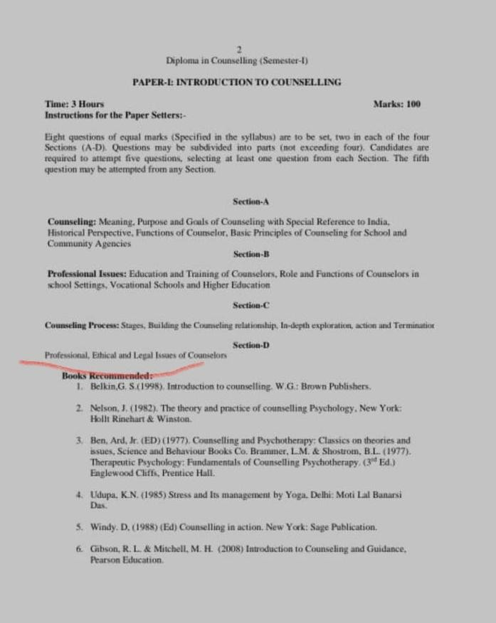

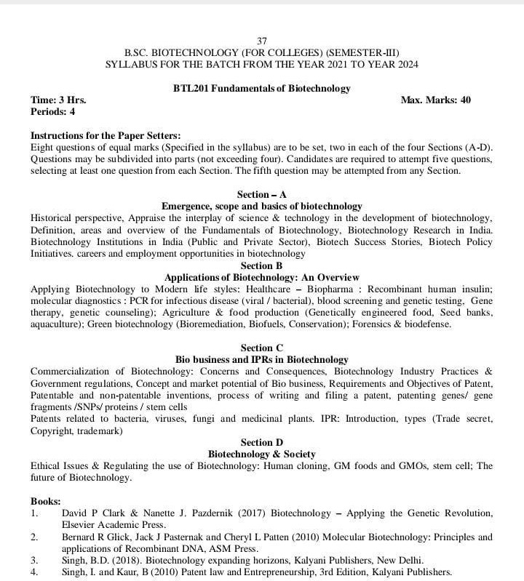

Bachelor of Vocation (B.VOC.) Mental Health Counselling (Semester-I) PAPER- I: MENTAL HEALTH AND COUNSELLING
Time:3 Hrs. Marks:75
Instructions for the Paper Setters: -
Eight questions of equal marks (Specified in the syllabus) are to be set, two in each of the four Sections (A-D). Questions may be subdivided into parts (not exceeding four).
Candidates are required to attempt five questions, selecting at least one question from each Section. The fifth question may be attempted from any Section.
Course Content:

SECTION-A
Mental Health: Concept, History, Psychological and Subjective Well-being , Nature, Need and Significance of Mental Health Counselling

SECTION-B
Purpose and goals of Counselling with special reference to India, Professional Issues of Mental Health &Counselling
SECTION-C
Counselling Skills, Counselor – Client Relationship, Role and Functions of Mental Health Counselors

SECTION-D
CounsellingProcess- Stages of Counselling, Ethical and Legal Issues

Bachelor of Vocation (B.VOC.) Mental Health Counselling (Semester-I) PAPER-II: DIAGNOSIS AND ASSESSMENT COUNSELLING
Time:3 Hrs. Marks:75
Instructions for the Paper Setters: -
Eight questions of equal marks (Specified in the syllabus) are to be set, two in each of the four Sections (A-D). Questions may be subdivided into parts (not exceeding four).
Candidates are required to attempt five questions, selecting at least one question from each Section. The fifth question may be attempted from any Section.

SECTION-A
Psychological Testing: Nature and characteristics of psychological Tests, Types of Psychological Tests, Uses and Misuses of Psychological Tests, Ethical issues in Testing

SECTION-B
Methods: Case Study Method, Interview (Types and Approaches), Observation

SECTION-C
Assessment of Intelligence, Interests and Aptitude

SECTION-D
Assessment of Personality: Projective and Non-Projective Techniques

Bachelor of Vocation (B.VOC.) Mental Health Counselling (Semester-VI) PAPER-III: RESEARCH METHODOLOGY
Time:3Hrs. Marks: 100
Instructions for Paper Setter: -
Eight questions of equal marks (specified in the syllabus) is to be set, two in each of the four sections(A-D) Questions may be subdivided into parts (not exceeding four). Candidates are required to attempt five questions, selecting at least one question from each section. The fifth question may be attempted from any section.

SECTION-A
Scientific Research: Meaning, Steps in Research process
Types of research and Hypothesis: Conceptualizations of research problems, types of hypothesis

SECTION-B
Research design: Meaning, nature, characteristics of a good design, purpose of research, types of research design
Experimental method, variables and their control

SECTION-C
Sampling: Concept, Types of Sampling (Probability and Nonprobability) , Problems of Sampling and their solutions.

SECTION-D
Qualitative Research Method: Nature & Types Ethical issues in Research and remedies

